Practical - 2
Practical Title: Semantic HTML5 Pages with Accessibility-Ready Structure
Develop static HTML5 skeletons for at least 10 StudentHub pages such as
Home, About, Register, Login, Dashboard, Events, Profile, Contact,
Admin, FAQ, and Feedback. Use semantic tags and accessibility-friendly
structure.

Theory

Are semantic tags such as header, nav, main, section, article, aside, and footer used properly?
Answer: Yes, semantic tags like header, nav, main, section, article, aside, and footer are used properly when they match the actual meaning and structure of the content. They help search engines and screen readers understand web pages, replacing old generic tags like div.
https://csegyan.com/HTML/html-semantic-elements.php

Are form labels, headings, image alt text, and navigation links accessible?
Answer :Yes, these elements are accessible when built correctly. Form labels need clear associations with inputs. Headings must follow a logical order. Image alt text should describe the visual content or mark it decorative. Navigation links need distinct, descriptive text for all users.

3. Is the page structure consistent across all pages?
Answer: Yes — same header, nav, and footer structure is repeated identically across all 10 pages for uniformity.

Implementation/ Output/Result
Created 10+ static HTML5 pages for the StudentHub portal: index.html (Home), about.html, register.html, login.html, dashboard.html, events.html, profile.html, contact.html, admin.html, faq.html, and feedback.html.

Evidence of Work (Screenshots)

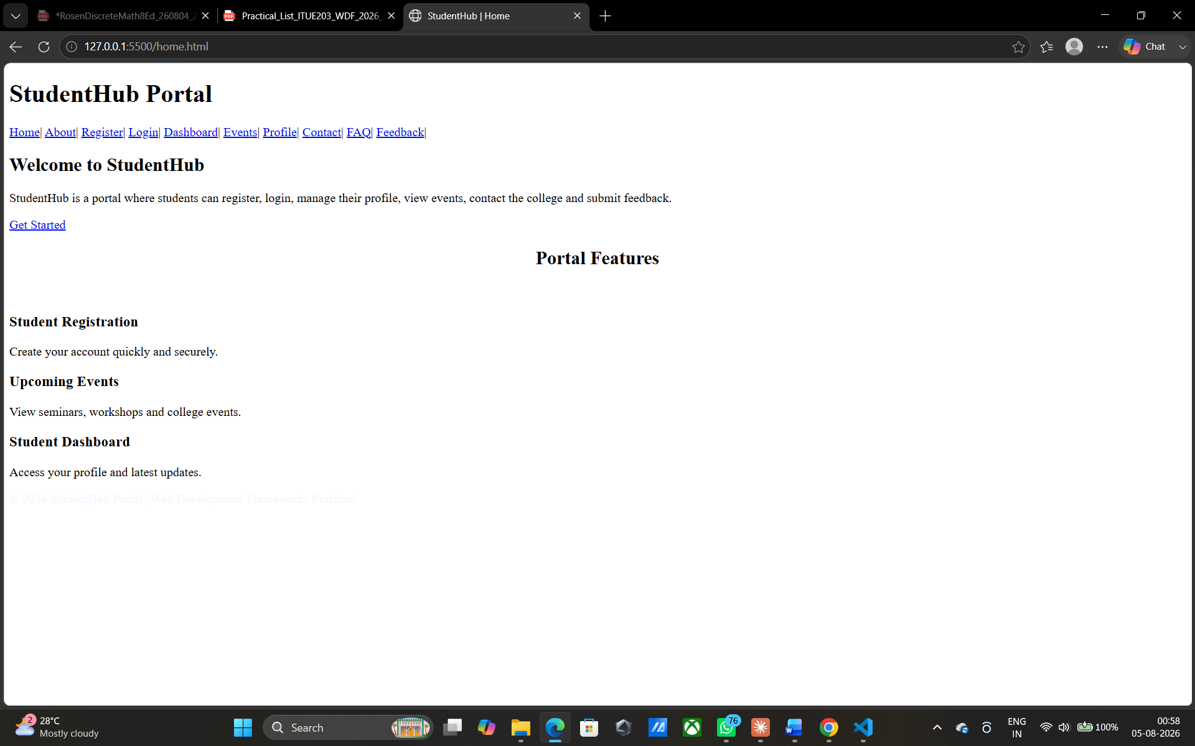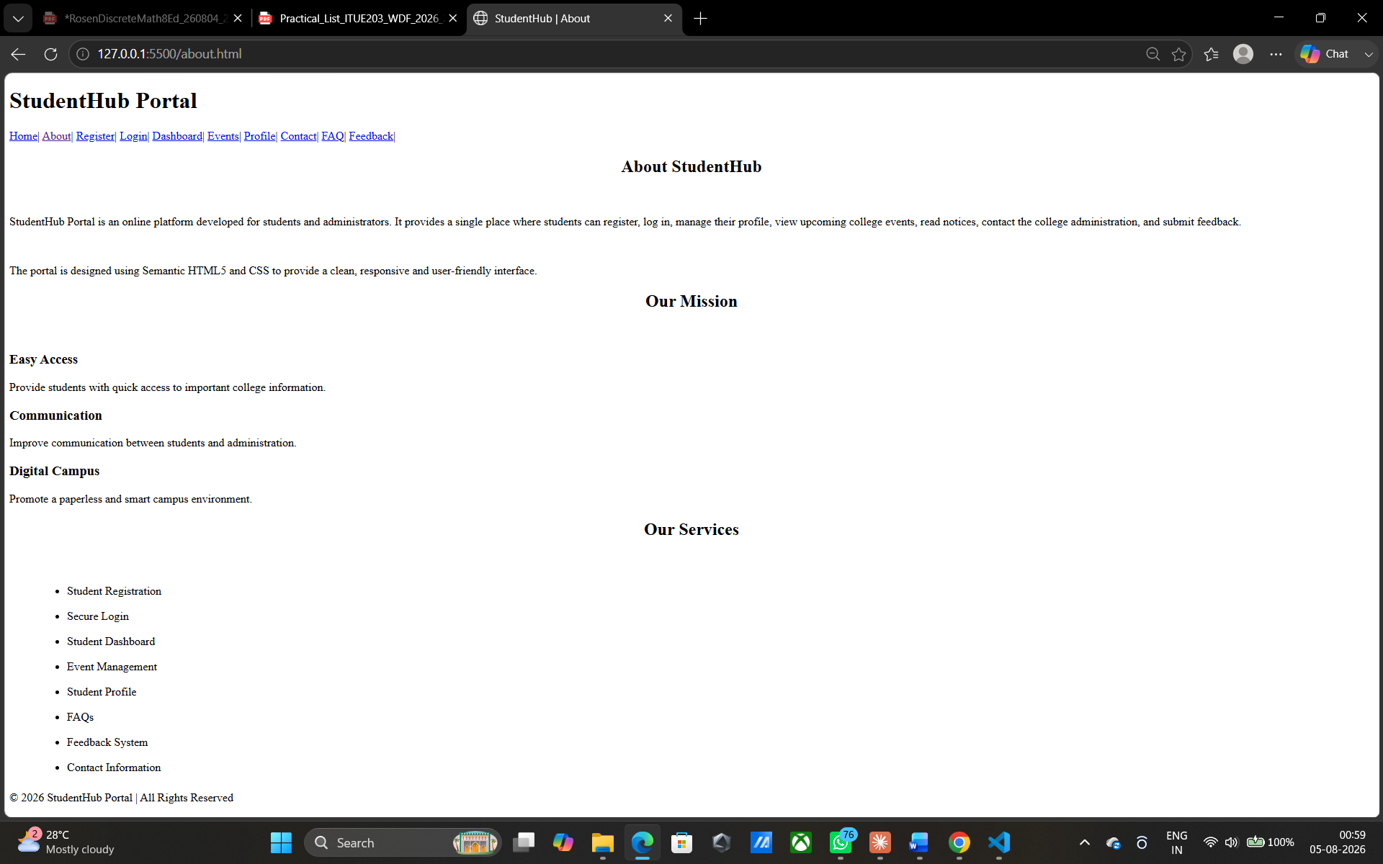
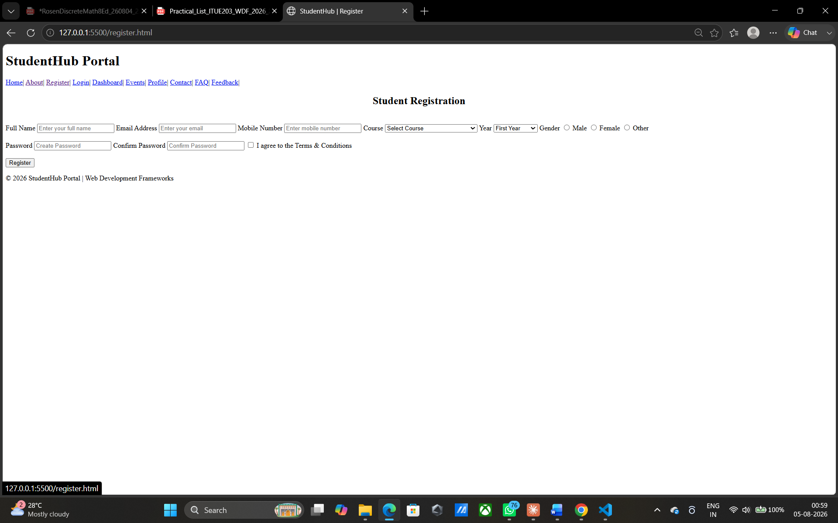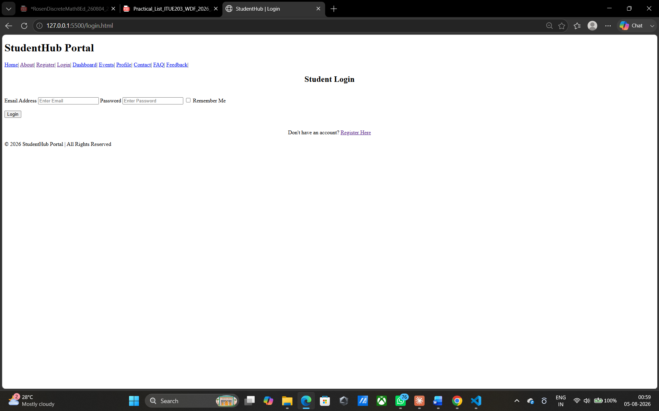
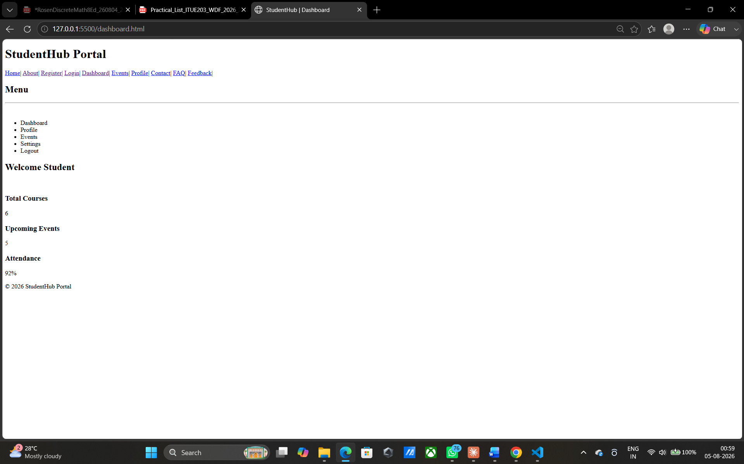
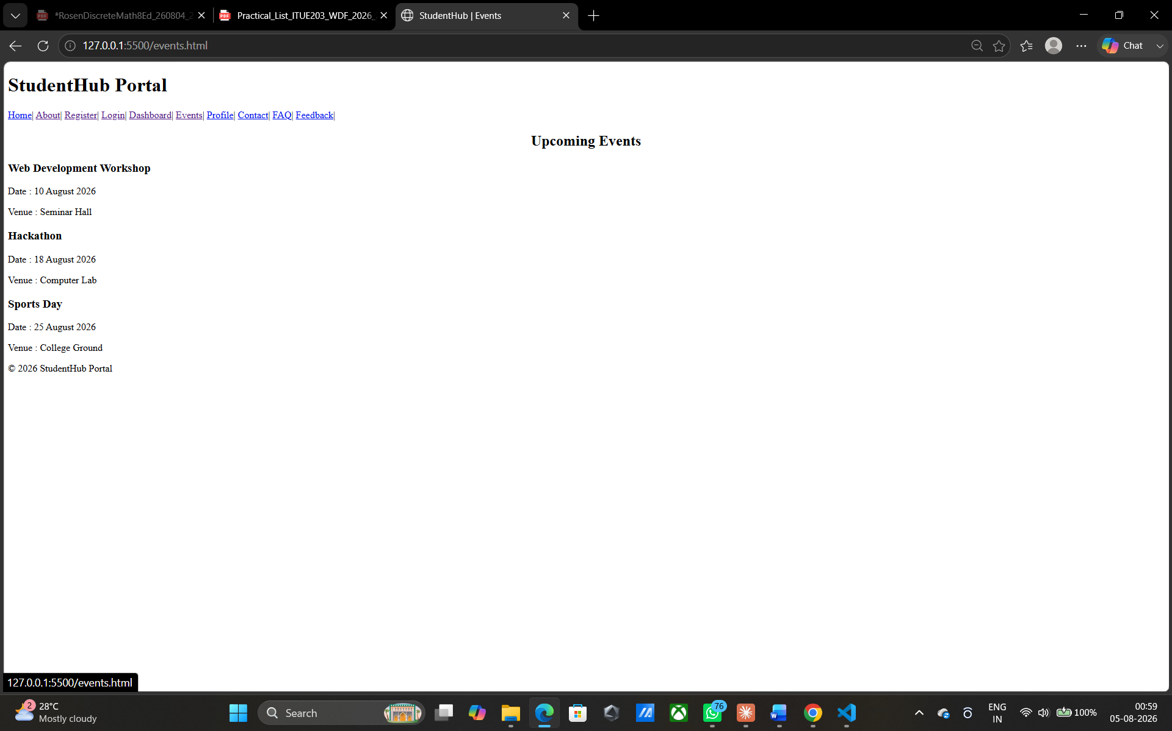
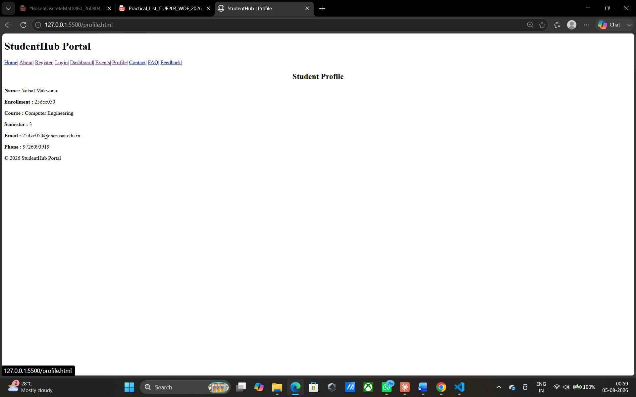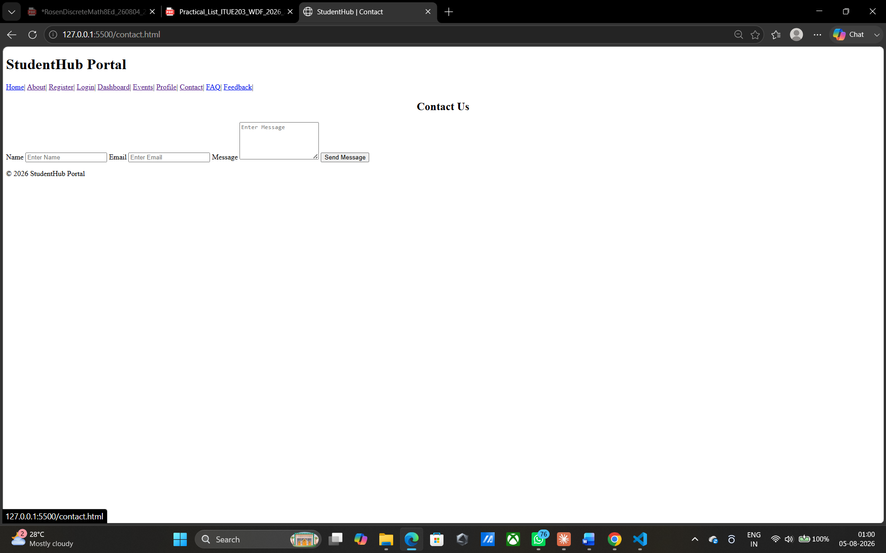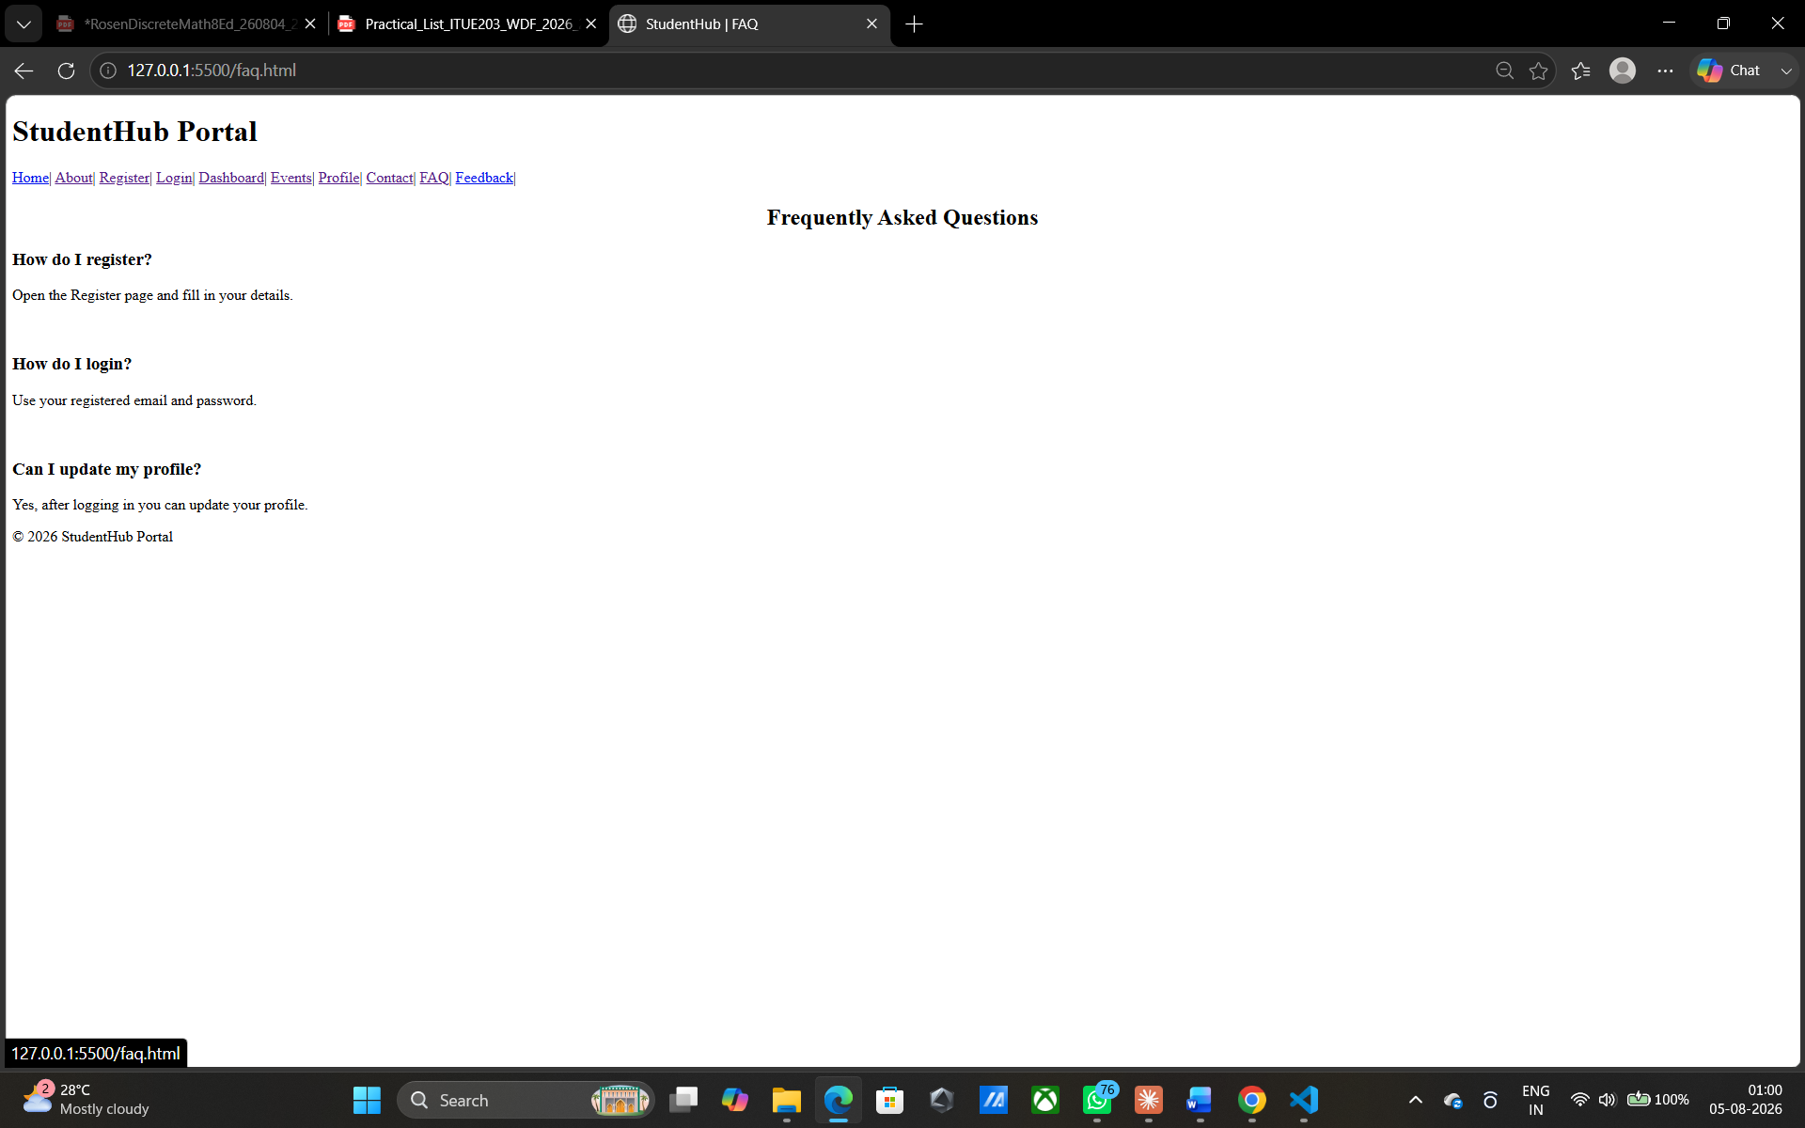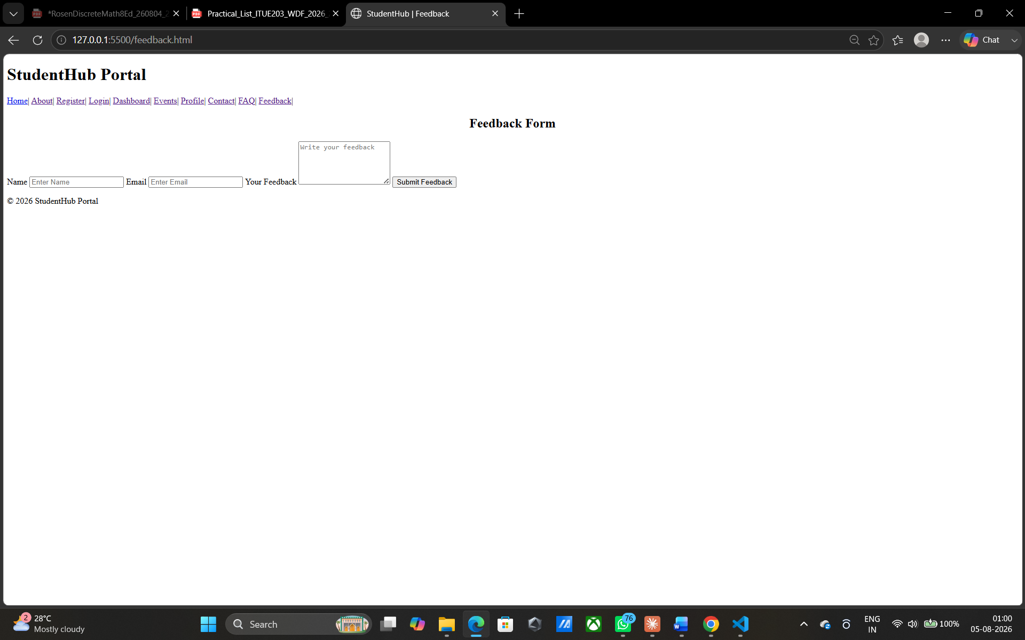

GitHub Repository Link:
https://github.com/vatsal1950/basics-of-html.git

Challenges Faced:
Maintaining consistency across 10+ pages — Manually copying the header/nav/footer into each new HTML file led to small inconsistencies (typos, mismatched class names). Solved by creating one "master template" file and copying from it for every new page.

Learning Outcomes:
Analyze and interpret how semantic structure improves both usability and search engine/accessibility compliance.

Faculty Remarks:

